BIRRONG BOYS HIGH SCHOOL
Promoting academic excellence and embracing diversity
Rodd Street, Birrong 2143 tel: 9644 5200 fax: 9743 7009
email: birrongboy-h.school@det.nsw.edu.au CRICOS Code 00588M

D Stevens B.A. Dip Ed – Principal

MOVEMENT OF FAMILIES IN 2018

Dear Parents/Caregivers

To assist our office staff in Term 1 2018. Please return the information slip below if

- Your family is moving during the holiday period, and your child will not be returning to Birrong Boys High School in 2018.
OR
- Your family will be on holidays and may return after Tuesday 30 January 2018. If this is, so please attach a copy of your child/ren’s flight details.

Students transferring to another NSW public school in 2018 should notify their Principal, Year Adviser and Office Staff prior to enrolling into a new school.
If any details have changed please fill out the attached form and return it to Birrong Boys High School as soon as possible so our details can be updated. This also includes Medicare details, emergency contacts, address, phone numbers, visas and any new citizenship details.

Thank you for your co-operation

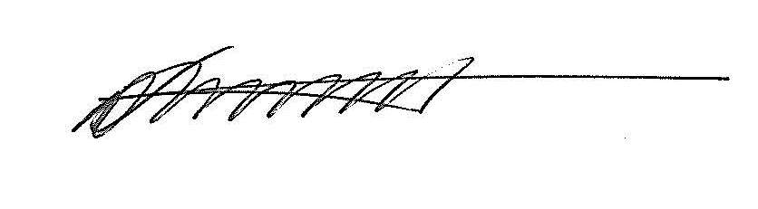
D. Stevens
Principal
15 November 2017

_______________________________________________________________________
Movement in 2018

Family Name: ______________________________________

Child/Childrens Nmae:
1.
2.
3.
4.

- My child/children WILL NOT need a class placement at Birrong Boys High School in 2018.

- My child/children will return to Birrong Boys High School after Tuesday 30 January 2018 due to extended overseas holiday. I have attached a copy of the flight details.

Parent/Carer’s Signature: _________________________________ Date: _____________________

